**Lab 2**

**Q1. Akshay scored 45,67,98 and 76 marks in four subjects respectively and wants to calculate average and percentage of marks. Help him to calculate the same. Write a java code that accepts input from command line argument and calculate the average and percentage marks scored by Akshay.**

**Source Code :**

**class Calculate**

**{**

**public static void main(String args[])**

**{**

**int ch;**

**double Average;**

**double Percentage;**

**double sum = 0;**

**for (int i = 0 ; i<args.length; i++)**

**{**

**sum = sum + Double.parseDouble(args[i]);**

**}**

**Average = sum/args.length;**

**Percentage = sum/(args.length*100)*100;**

**System.out.println("Average of marks is : " + Average);**

**System.out.println("Percentage of Student is : " + Percentage);**

**}**

**}**

**Output:**

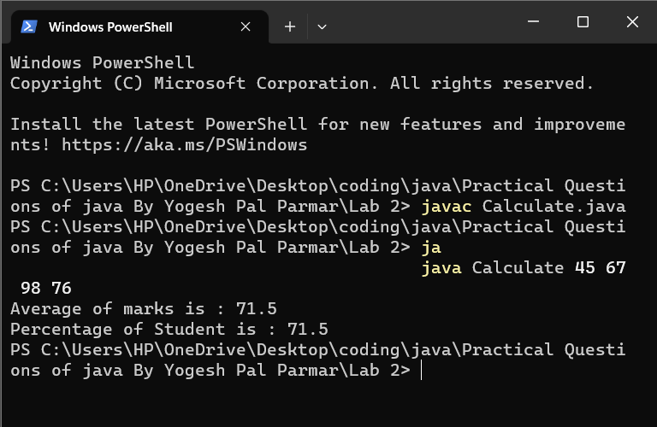

**2. Akshay wants to calculate the area of three different shapes “square, rectangle and triangle”. Create three different methods having same name as "claculateArea()". To calculate area of these three shapes. Take input from command line as height, width and length.**

**Source code:**

**import java.util.Scanner;**

**class Area**

**{**

**public static void main(String args[])**

**{**

**Scanner sc = new Scanner(System.in);**

**System.out.println("Enter your choice: ");**

**int ch = sc.nextInt();**

**int areaRct;**

**int areaSq;**

**double areaTri;**

**switch(ch)**

**{**

**case 1:**

**areaRct = calculateArea(args);**

**System.out.println("Area of Rectangle is: " + areaRct);**

**break;**

**case 2:**

**areaSq = calculateArea(args);**

**System.out.println("Area of Square is: " + areaSq);**

**break;**

**case 3:**

**areaTri = calculateArea(args);**

**System.out.println("Area of Triangle is: " + areaTri);**

**break;**

**default:**

**System.out.println("Invalid Choice :");**

**}**

**}**

**public static int calculateArea(String args[])**

**{**

**int area = 1;**

**for(int i=0; i<args.length; i++)**

**{**

**area = area * Integer.parseInt(args[i]);**

**}**

**return area;**

**}**

**public static int calculateArea(int args[])**

**{**

**int area = 1;**

**for(int i=0; i<args.length; i++)**

**{**

**area = area * args[i];**

**}**

**return area;**

**}**

**public static double calculateArea(double args[])**

**{**

**double area = 1;**

**for(int i=0; i<args.length; i++)**

**{**

**area = area * 0.5 * args[i];**

**}**

**return area;**

**}**

**}**

**Output:**

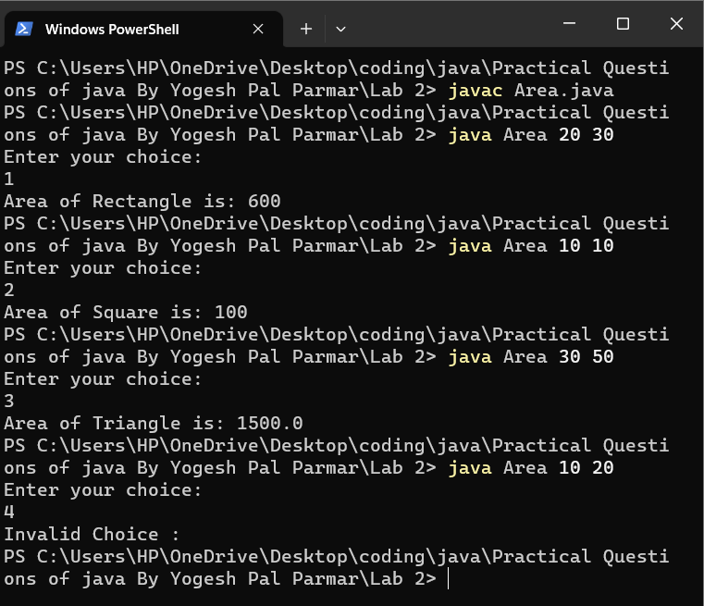

**Q3. Akshay wants to calculate sum of even digits of a number. Take input from command line and calculate the sum of even digits.**

**Source code:**

**class Sumeven**

**{**

**public static void main(String args[])**

**{**

**int num = Integer.parseInt(args[0]);**

**int rem;**

**int sum = 0;**

**while(num > 0)**

**{**

**rem = num%10;**

**if(rem%2 == 0)**

**{**

**sum = sum+rem;**

**}**

**num = num/10;**

**}**

**System.out.println("Sum of the even digits of the entered number is : " + sum);**

**}**

**}**

**Output:**

